Technical Documentation

Unit 10

P7

[Robbie Wackett]

[Dragon Jumping Game]

# Data Dictionary

|  |  |  |
| --- | --- | --- |
| Name | Data Type | Purpose |
| Dragon | Object | The purpose of the dragon is to have the player control it. |
| Dawn | Backdrop | The first background that the players plays in. |
| Desert | Backdrop | The second background that the player plays in. |
| Night sky | Backdrop | The third background the player plays in. |
| Sprite 1 | Object | A floor which the obstacles and the dragon is placed on. |
| Sprite 2 | Obstacle | An obstacle that the player must avoid touching. |
| Sprite 3 | Obstacle | An obstacle that the player must avoid touching. |
|  |  |  |

# Input-Process-Output

OUTPUT

PROCESS

INPUT

The Sprite moves up allowing the player to dodge the obstacles.

The player presses the spacebar.

The Sprite moves up the y-axis.

The Sprite moves up allowing the player to dodge the obstacles.

The Sprite moves up the y-axis.

The player presses the up-arrow key

# Control Method

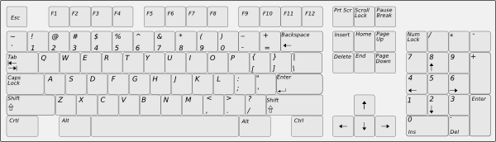

Pressing spacebar moves the sprite upwards.

Pressing up-arrow key also moves the sprite upwards.

Pressing spacebar and then pressing up-arrow key or vice versa will allow the player to double jump.

# Algorithm Design

|  |  |
| --- | --- |
| Pseudocode OR Flowchart | Code Blocks |
|  |  |